**CMP4271: Online diary - Employability Game**

This week groups had to do a game using skills which employers seek in the employee. The group was formed of four members and they came up with the idea of creating a monopoly type of game. The game was called Employability Game, and they had to make a presentation in front of the class about it.

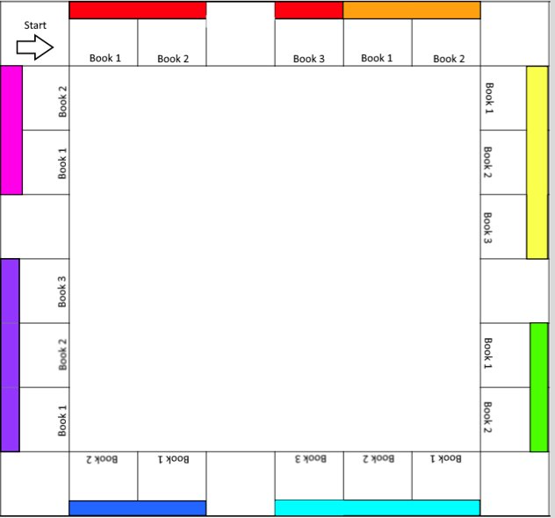Like monopoly, Employability game was playable by 2 or more players. Each player gets a piece of a stickman that they can move around the board using a six number dice, which shows them the amount of moves they can make per turn. As you can see on the picture on the right side, this was the game board. It showed the start from where the players will begin the game. After the start however, the players have x amount of money. The reason for x amount of money is that the team members were unsure of the amount of money they had to input. After the player has used the dice, they move corresponding on the moves they acquired from the dice, e.g. dice shows 5 moves, the player makes 5 moves. Before each player made a move, the dice had to be casted, for the player to know how many moves they had to make.

As you can see on the board there is ‘’Books’’, and they are different colours, representing the knowledge the books give. Each book had different employability skills which are required by the player for them to win the game. The game is won by the player who had all the books and the knowledge of the skills. For a player to acquire the knowledge from the book they had to ‘’read’’ it. To read a book the player had to skip two turns and wait until they have read the book. The players got money each turn depending on the amount of knowledge and books they had acquired beforehand (more books/knowledge more money). The money was representable by plastic pound currency in forms of five, ten, twenty, fifty and a hundred. The knowledge was represented in cards which can be traded among the players. The trades were accomplished by two players with mutual agreement to them and each trade one card will be traded for another. It varied from one card to another as some were cheaper than others. All cards were respected, however, because each card gave the player money per turn. If one player didn’t have enough money to buy a card from another player, the trade will be cancelled as the player cannot pay for the book, they would’ve wanted.

Books are purchased from different locations; the different colours show the costs of each book. For example, a red book will be much cheaper than a blue or a purple book. The players had to go multiple times around the board until all the books and knowledge has been acquired. Depending on sheer luck because of the dice, the time it would have taken the players to have won the game can vary from 20-30 minutes.